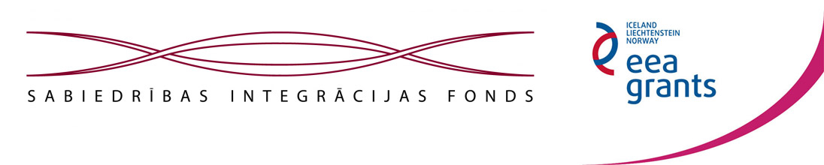

BEING IN THE SAME BOAT REQUIRES ROWING TOGETHER

We are very glad and with pleasure announce to Kraslava district residents and cooperation partners that the union's “Family support center “Openness”” project “Being in the same boat requires rowing together” is financed by the European Economic Area (hereinafter – EEA) Financial Mechanism 2009- 2014 program's “NGO Fund” subprogram “Non-governmental organizations project program”. The project is financially supported by Iceland, Liechtenstein and Norway.

This is already the second EEA-funded project, which will be implemented by the union “Family support center “Openness””. The first project, which was aimed at improvement of the situation of families, we have successfully implmented in 2013- 2014, for what we have received a positive assessment of the Fund. We are particularly grateful to the Kraslava district council for its co-funding, to the project partner - Kraslava district social service professionals, district local governments, other institutions and unions, as well as the whole project team!

In the framework of the current project we will pay attention to actualization, recognition, and promotion of Kraslava town and district NGOs, especially to the integration of minority NGOs in society in order to promote cooperation, fellowship, unified society, intercultural dialogue, understanding of the Latvian people and the culture and traditions of other nationalities.

The project will be launched with an activity - the organization of day camps for children and youth, in which both Latvian and Russian-speaking children will be able to participate. The priority will be children and young people's activity and desire to act in the area of social integration – to learn deeper the culture and traditions of Latvia, district and native town, promote them to others, be creative to their own and other people's benefit. First of all, to the camp will be invited children and young people aged up to 16 years, who did not have an opportunity to participate in other camps this year.

The activity will contribute to the establishment of an inter-ethnic NGOs network, recognition, collaboration, and an expanded information space, thus ensuring for small unions economically favorable information support, because only a few of them can afford to build and maintain their own website and acquire a wide range of informative space.
On the first level of the project the medium-term strategy for 2015-2020 on the local level will be developed for the union “Family support center “Openness””, which will include the analysis of the center performance, put forward the priorities for the next period, promoting union work's regularity and growth in a certain perspective. During the project a set of integrating and educational activities, focused on the achievement of the project objectives, will be carried out.

The basic activities of the project will contribute to the target audience – minorities' intercultural dialogue, awareness, education about Latvian and non-Latvian culture and traditions, the improvement of Latvian language proficiency, motivate project participants' integration and active participation in society. The activities anticipate awareness about annual traditions, their deeper exploration, training for initiative development and project preparation, cultivation of craft skills, Latvian culinary novelties and other topical issues.
At the end of the project, there will be organized a mutually enriching and society integration task promoting event – Kraslava and other district local government Latvian and Russian-speaking NGOs fellowship festival, which will carry out the task of successful different cultures co-existance, development and promotion of a mutual dialogue. In the framework of the festival there will be organized an exhibition/fair of art and craft work prepared by different unions and in training. Carrying out the project in partnership with “Kraslava Latvian union” we will unify people strenghtening their Latvian language skills, understanding of the Latvian and other folk culture and traditions, and also promote human determination, teaching them new skills and increasing their confidance.

EEA Financial Mechanism website in Latvia: www.eeagrants.lv
EEA Financial Mechanism official website: www.eeagrants.org, www.norwaygrants.org
Society Integration Foundation website: www.sif.lv

Announcement

We welcome Kraslava town children and young people, 7 to 16 years old, from Latvian and Russian-speaking families to apply for day camp at the end of the summer holidays from August 24th to August 28th on the phone: 29808802!

The priority will be children and young people's activity and desire to act in the area of social integration – to learn deeper the culture and traditions of Latvia, district and native town, promote them to others, be creative to their own and other people's benefit! At first, those children and young people are welcome to the camp, who did not have the opportunity to participate in other leisure camps this year.
Children and youth camp is organized in the framework of the project “BEING IN THE SAME BOAT REQUIRES ROWING TOGETHER”.

Union's “Family support center “Openness”” board and project administration

